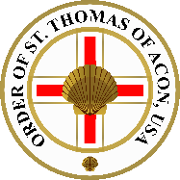

The Commemorative Order of Saint Thomas of Acon USA BY-LAWS
Mt. Nebo Chapel No. 34

Article I
Place, dates and times of meeting.

The Chapel shall meet at least twice each year. At least one meeting a year shall be in the first two quarters of the year and at least one meeting a year shall be in the last two quarters of the year at a location and time determined by the Worthy Master. The Chapel may meet within the State of Utah as well as Wyoming, or Nevada provided permission (recognition) has been granted by the Grand Lodge of that jurisdiction, if required. The Worthy Master shall within 30-days of his installation make known the dates of the meetings during his tenure. The Secretary shall inform the Knights of the Chapel of these dates as soon as practical.

Article II
Election of Officers and Installation.

The Worthy Master shall be elected by the will of the assembled Knights and the Treasurer shall be elected by Proposition, both elections occurring at the Installation Meeting which shall be the last meeting preceding September 1 of each calendar year.

The Master-elect shall be Installed immediately and will appoint and invest the Prior and other Officers and invest the Treasurer. The Sentry shall be elected at the second regular meeting of each calendar year.

Article III Candidates.

Proposals for membership shall be presented by the Chapel Committee consisting of The Worthy Master, Eminent Prior, Treasurer, and Secretary. Suggestions may be presented to this Chapel Committee by any member for consideration. All members of the Chapel will be notified of those proposed for membership.

The election of candidates for admission, joining or re-joining shall be by voice vote, two nay votes shall exclude.

Article IV
Fees and Subscriptions:

The Annual subscription is payable in advance on August 31st, and the admission fees and fees for joining and re-joining, shall be such sums as are determined from time to time by resolution in Open Chapel after due notice of the Summons. The amounts shall include all fees and dues payable to the Grand Master’s Council, the Grand Preceptor’s Council (when applicable) and any payment or financial liability incurred by the Chapel and/or candidate for membership.

The financial year is September 1st to August 31st.
Article V Treasurer.

The Treasurer shall receive all fees, dues, etc. and shall deposit them in the name of the Chapel in a bank, building society or other financial institution approved by the Chapel. He shall pay all accounts, and shall, at the Installation Meeting occurring on the first meeting of each calendar year, present a duly examined balance sheet of the Chapel accounts made up to August 31st of the preceding year, together with a statement of income and expenditure for the period ending on that date.

Article VI
Payment from Chapel Funds.

Payment of any sum other than ordinary purposes, may be made, only by resolution of the Chapel, of which notice has been given on the summons, except in the case of emergency, when such payment may be authorized by the Worthy Master and reported to the Chapel at the next Regular Meeting.

Article VII Arrears of Subscription.

A member whose current subscription is more than six months in arrears shall not hold Office in the Chapel. If he be more than six months in arrears, he will be advised in writing that if his subscription is not paid by the Chapel’s financial year-end August 31st he may be excluded.

Article VIII Secretary.

The Secretary shall keep Minutes of proceedings of the Chapel and separately, of any Chapel Committee. He shall issue summons for all Chapel meetings, at least fourteen days in advance, to every member of the Chapel.

Article IX
Chapel Committee and election of Examiners of Accounts.

The Chapel Committee shall consist of the Worthy Master, Prior, Treasurer, and Secretary Two Examiners of Accounts shall be elected annually at the second regular meeting of the calendar year.

Article X Resignation.

A brother wishing to resign from the Chapel shall give notice, either in Open Chapel, or by letter to the Secretary and, on payment of all dues shall be entitled to a Clearance Certificate.

A member of the Chapel who fails to attend two consecutive meetings, without sending a satisfactory “regret” may be dropped from the rolls of the Chapel. His non-participation will be considered his de facto “Resignation” and a Clearance Certificate may be issued. This provision will not apply to “Honorary” and “Emeritus” members.
Article XI Chapel Effects.

The jewel and furniture of the Chapel are the property of the Worthy Master and Eminent Prior for the time being, in trust for the members. The Warrant of Constitution is the property of the Grand Master, and the Worthy Master shall be responsible for its safe custody, and shall produce it at every meeting of the Chapel. In the event of the erasure or dissolution of the Chapel, the Warrant, Jewels, Furniture and any other effects shall be surrendered to the Grand Master’s Council.

Article XII Alteration of By-laws.

Notice of motion of any alteration of, or addition to, these by-laws must be given at a Regular Meeting. They shall appear on the Summons for the next Meeting and, if approved, the alterations or additions shall be submitted for countersignature to the Grand Preceptor (when applicable) and to the Most Worthy Grand Master for approval, and shall not be effective until so approved.

Article XIII Presentation of By-laws.

A copy of these by-laws shall be presented to each new member of the Chapel and to the Worthy Master at his Installation.

Adopted in Open Chapel on the 19th day of September in the year of our Lord 2021.
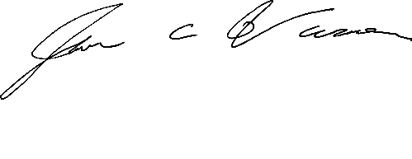
Sir Jason of Carbon County, Worthy Master __________________________ Jason C. Varner
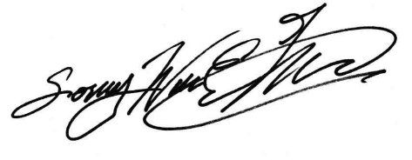

Sir William of Kintail, Secretary __________________________ William E. McCraw

Approved on the 19th, day of September in the year of our Lord 2021.

Approved on behalf of the M∴W∴ Grand Master, Sir Joseph of Toftingall, KH

Sir Seth of Edinboro, Grand Secretary
Seth C. Anthony

Dated , 20_____.

At the Consecration of Mt. Nebo Chapel No. 34 on the 19th day of September in the year of our Lord 2021the following FEES and ANNUAL SUBSCRIPTION applied:
Admission fee: $400.00 (includes first year’s subscription, cap, mantle, tunic, belt, ritual & scallops).
Joining (Plural) fee: $150.00 plus cost of uniform if required. Re-joining fee: $75.00
Annual Subscription: $60.00
Life member fee: $1200.00 (70-74: $600; 75+ years old: $300.00).

